Result Summary

# Summary for Models Without Regularization

## Solver=’lbfgs’

For this implementation, ***majority*** Random Under Sampling was conducting on X and Y and **NOT** on the training data.

* Iterations to converge: 40.
* There was a 0.004285247890386867 difference between training and test predictions.
  + Training Accuracy: 0.796688580
  + Test Accuracy: 0.80097382

* Since the test data has a higher accuracy rate than the training data, this modeling implementation is not overfitting. If it were overfitting, the training data would have performed much better than the test data.

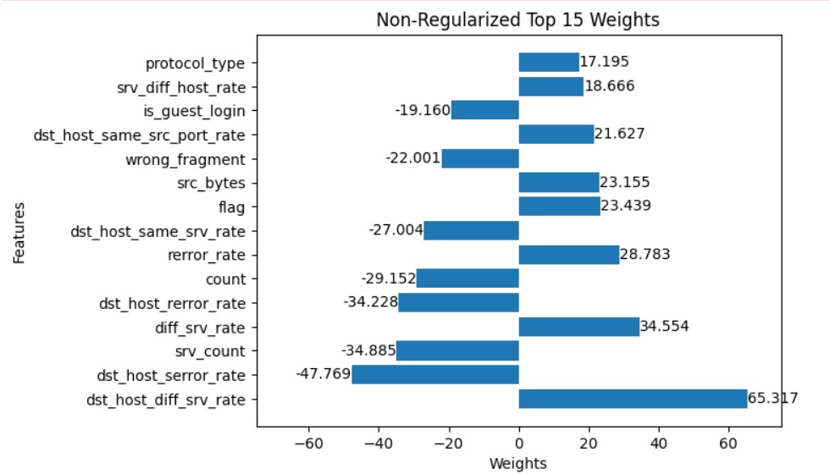

When looking at the data in kddcup99_csv.csv, there is very little variance in the features listed above. For example, dst_host_diff_srv_rate values range from 0.00 to approximately 1. While other features have much larger ranges.

# L1 vs L2

# L2 Comparison

The test data behaves the similarly:

